Finance FAQ Chatbot using Retrieval-Augmented Generation (RAG)

Introduction
This project presents FinBot, a Finance FAQ Chatbot developed using the Retrieval-Augmented Generation (RAG) architecture. The objective of this project is to answer consumer finance questions using trusted information from the Consumer Financial Protection Bureau (CFPB) website.
Unlike a traditional chatbot, our system does not answer only from the Large Language Model's general knowledge. Instead, it first retrieves relevant information from the CFPB knowledge base and then generates the final answer using only the retrieved documents. This approach helps improve answer accuracy, reduces hallucinations, and provides source-based responses.

1. System Architecture
The overall architecture consists of the following stages:
CFPB Website
↓
Crawler
↓
Extraction
↓
Chunking
↓
Embedding
↓
ChromaDB (Vector Database)
↓
Retriever
↓
GPT-4.1-mini
↓
FastAPI Backend
↓
React Chat Interface

Pipeline Description
Scraping
The crawler downloads finance-related webpages from the CFPB website using the Requests and BeautifulSoup libraries. The downloaded webpages are stored in a raw JSON file.
Extraction
The extractor cleans the downloaded webpages by removing navigation menus, footer text, legal disclaimers, blank lines, and unnecessary spaces. Only useful finance-related information is retained.
Chunking
Large webpages are divided into smaller chunks of approximately 300 words. Smaller chunks improve retrieval performance and reduce the amount of text sent to the language model.
Embedding
Each chunk is converted into a vector embedding using OpenAI's text-embedding-3-small model.
Vector Database
The embeddings and document chunks are stored in ChromaDB using a PersistentClient. ChromaDB performs semantic similarity search.
Retrieval
When the user submits a question, the question is converted into an embedding and ChromaDB retrieves the most relevant document chunks.
Reranking
A separate reranking stage was not implemented in this project. The retrieved chunks are directly passed to the language model. Reranking is identified as future work.
Generation
The retrieved chunks and the user question are sent to GPT-4.1-mini to generate the final answer.
Chat Interface
The React frontend displays the chatbot interface, while FastAPI acts as the backend API connecting the frontend with the RAG pipeline.

2. Retrieval and Generation Design
Figure 2 – Swagger API Screenshot
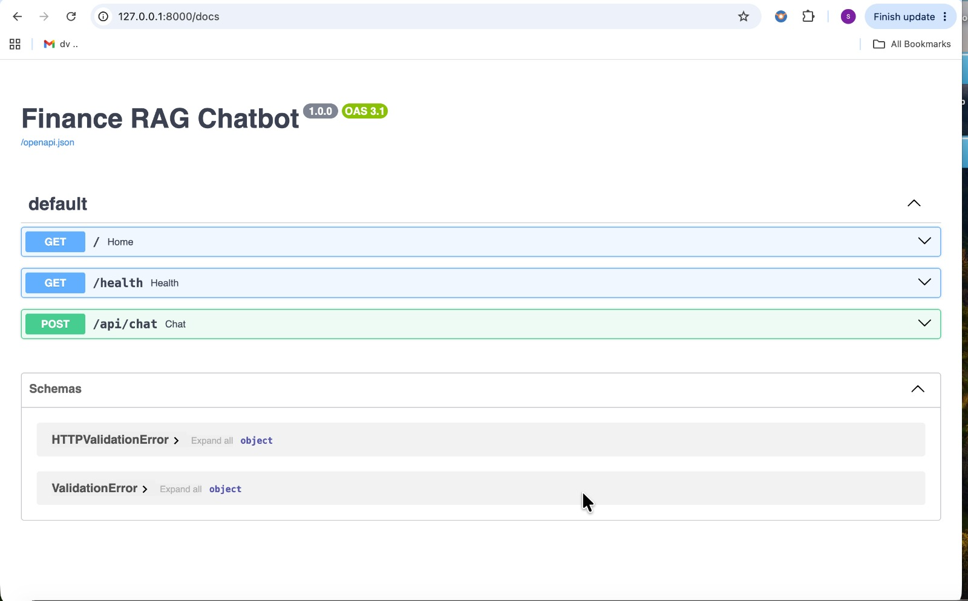
Figure 2. FastAPI API Testing using Swagger
We selected OpenAI text-embedding-3-small as the embedding model because it generates high-quality semantic embeddings while keeping API costs relatively low.
We selected GPT-4.1-mini as the Large Language Model because it generates accurate natural-language responses using the retrieved CFPB documents.
The system prompt instructs GPT to:
- Answer only using the retrieved CFPB information.
- Avoid generating unsupported information.
- Return a refusal message when sufficient context is unavailable.
The chatbot displays source links along with every answer, allowing users to verify the information.
To avoid copyright concerns, our implementation summarizes the retrieved information instead of copying large sections of text. Long quotations are avoided.
When the retriever cannot find sufficient supporting information, the chatbot returns a refusal message instead of generating an unsupported answer.

3. Chunking Strategy
Figure 3 – Sample Chunk Screenshot (chunks.json)
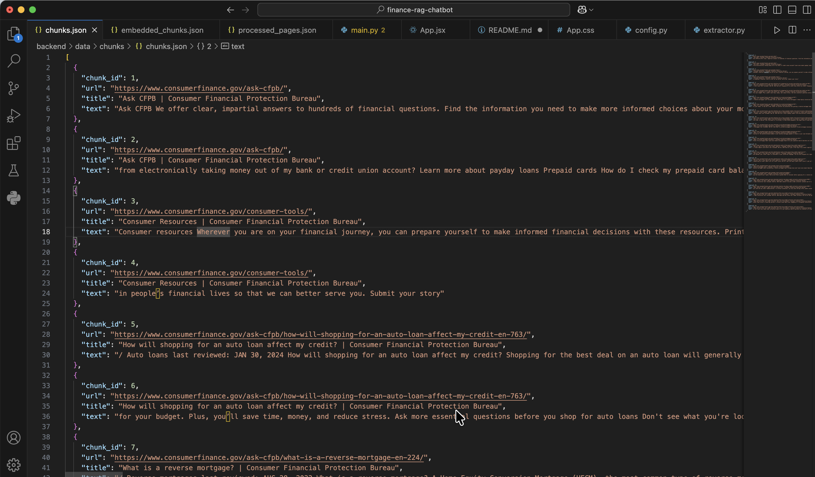
Figure 3. Example of a Document Chunk
Our implementation uses a fixed-size chunking strategy of approximately 300 words per chunk.
Each chunk contains:
- Chunk ID
- Document title
- Source URL
- Chunk text
The Chunk ID uniquely identifies each document stored in ChromaDB.
We did not compare multiple chunking strategies or implement a re-chunk experiment. Similarly, re-indexing without re-crawling was not implemented. These improvements are identified as future enhancements.

4. Version Control and Team Collaboration
GitHub was used for version control and collaboration throughout the project.
The work was divided as follows:
- Product Manager (Keerthi Nukala )– Project planning and coordination.
- Backend Developer (Sai Sree Narla) – Developed the crawler, extractor, chunking pipeline, embedding generation, ChromaDB integration, FastAPI backend, retrieval logic, and OpenAI integration.
- Frontend Developer (Sarath Bontha) – Developed the React chatbot interface and integrated it with the backend APIs.
- Data Analyst (Deekshitha sadhu) – Assisted with testing and validating chatbot responses.
GitHub was used to maintain the project source code and coordinate team contributions.

5. Ethics Considerations
The following ethical considerations were addressed during the project.

Risks
- AI hallucinations
- Incorrect financial advice
- Copyright concerns
- Misleading responses

Mitigations
- Used only publicly available CFPB webpages.
- Retrieved supporting documents before answer generation.
- Displayed source links for transparency.
- Returned refusal messages when sufficient information was unavailable.

Current Limitations
- Limited CFPB knowledge base.
- No reranking implementation.
- No multilingual support.
- No automatic crawler updates.
With additional time, these limitations can be addressed through future enhancements.

6. Challenges and Solutions

Challenge 1 – OpenAI API Quota
Initially, embedding generation failed because the OpenAI account did not have sufficient API quota.
Solution
Billing was enabled, embeddings were regenerated, and successfully stored in ChromaDB.

Challenge 2 – Retrieval of Irrelevant Results
Initially, ChromaDB returned finance-related results even for unrelated questions.
Solution
A similarity threshold was introduced. If no relevant document is found, the chatbot returns a refusal message instead of generating an incorrect answer.

7. Evaluation
Figure 4– React Chatbot Screenshot (APR Question)
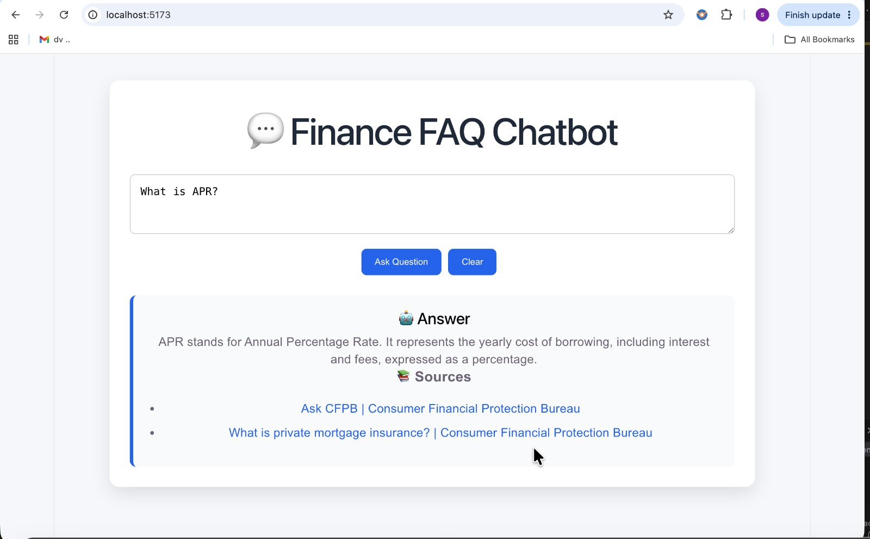
Figure 4. Finance FAQ Chatbot Answering a Consumer Question
Figure 5 – Refusal Response Screenshot
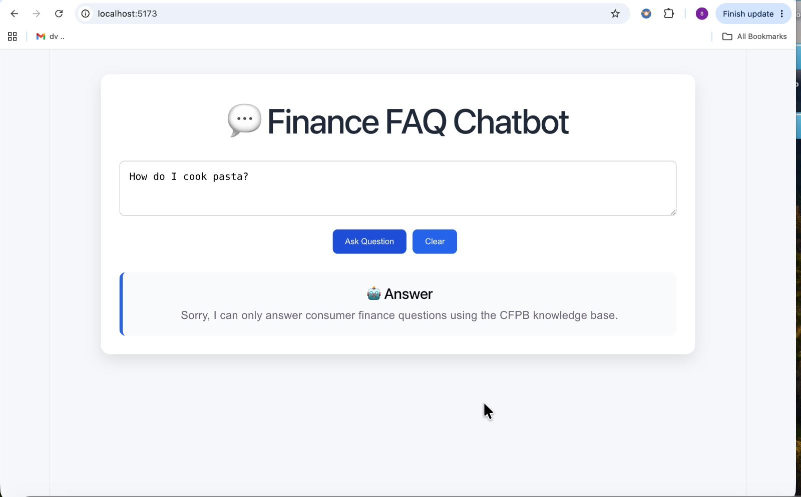
Figure 5. Refusal Response for an Out-of-Scope Question
The chatbot was evaluated using finance-related questions such as:
- What is APR?
- What is a reverse mortgage?
- What is a credit report?
The chatbot successfully retrieved relevant CFPB information and generated accurate responses.
For unrelated questions such as:
- How do I cook pasta?
the chatbot correctly returned a refusal message.
A formal evaluation using confidence intervals, paired significance testing, and fifteen hand-labeled failure cases was not completed during this implementation. These evaluation techniques are recommended for future work.

8. Future Work
Future improvements include:
- Implement resume crawling to continue downloading new webpages without revisiting previously crawled pages.
- Implement reranking to improve retrieval accuracy.
- Compare multiple chunking strategies.
- Support incremental updates to ChromaDB without rebuilding the entire knowledge base.
- Increase the number of CFPB webpages included in the knowledge base.
- Support multilingual question answering.
- Perform comprehensive evaluation using benchmark datasets and statistical analysis.

Conclusion
This project successfully demonstrates a Retrieval-Augmented Generation (RAG) chatbot developed using React, FastAPI, OpenAI, and ChromaDB. The chatbot retrieves trusted CFPB information before generating responses, helping reduce hallucinations and improve answer reliability. Although advanced features such as reranking, incremental crawling, and comprehensive evaluation remain future enhancements, the project successfully implements the complete RAG pipeline from web crawling to answer generation and provides a strong foundation for future development.

